Class 1: Types of Communication
Lecture
- Why science communications are important
  - Opening and creating opportunities
- Had to have strategies to effectively communicate science and articulate it to the audience
- If you can teach something than you understand it
- READ THE GUIDE
- Word you use can change the meaning of a sentence

Types of communication
- Posters
- Presentations/ Conference
  - Learning to speak and present your work will have great effects in your life, even if it’s not you are in a scientific career
- Journal
  - If you can write and communicate them well, you can write anything
- Social media
  - Become so much more important in science
  - Amplify message
  - Goes to anyone in the world while journals only go to a group of people that had access to it
- Research grants
  - Important to write grants
- Podcast

Know your audience
- Sometimes you know your audience and often times you don’t
- Makes a difference once you pitch your talk
- Different versions of the same information
- Engage your audience by asking questions
- Acknowledge things that the audience is going through things as a collective a whole
Lay summary
- Know your audience
- Structure, organize and roles
- Assume grade 8 level
- Simple summary that avoids jargon and the audience is able to understand

Social media
- Don’t sacrifice clarity for brevity
- Use images and videos to augment your content
- Use # and @ to engage others and encourage retweets
- Live tweet from conference and academic events
- Use analytics to work out what engages your audience most
- Share perspectives or take a strong stance in topical content
  - Blend you are of expertise into you views to provide a unique perspective only you could possibly provide
- Engage and respond to tweets from those with higher follower counts within topics that interest you more visibility
  - Don’t be afraid to partake in real discussion
- Be yourself
  - Don’t cultivate an online personality that doesn’t reflect who you are. Remain true and consistent to your core values, and be vulnerable in making those values known
- Be polite, but edgy, sarcastic, witty in your tone
- Be respectful- treat people as you would in person
Layman’s Summary Paper
- brain injury- ICU – death
  - Because of pulling the plug/ withdraw support
- Problem:
  - In ICU good at predicting who will not recover
  - No predictors of good outcomes
  - Not good at predicting based on good
- Use machine learning to see if brain scans can be used to generate positive predictors
- Can we see how well they recover
- Scan their brain passively
- Gave the info to the machine and the machine was able to 80% accurate tell who could survive
- Fully automated tool for identify who are able to recover
  - The originally stuff like checking pupils and see hands squeezing

ARTICLE POINTS
- The main goal of the paper is to find out if a special brain scan (fMRI) can help doctors predict if patients in a coma or unresponsive after a serious brain injury will have a good recovery or not within six months.
- Many people with brain injuries often end up in the ICU due to the severity of the trauma and most often this leads to death
  - The reason why this occurs is often due to the family wanting to withdraw life support
- Problem
  - There are lots of ways to know whether someone will not survive
  - However, there are no predictors to know whether someone will survive
- This study uses machine learning to see if the brain scans can be used to generate positive predictors and you can see how well they recover
  - Patients underwent a brain scan for 5.5 mins
  - Glasgow outcome scale was used to indicate patients classified as good or poor outcomes
- The brains were scanned passively, and this information was given to the machine which had an 80% accuracy of predicting survivability
  - Fully automated tool for identify who are able to recover
    - Originally checking pupils and seeing if simple motor movements such as hand squeezes were the main predictors used
  - The most significant predictors of recovery were the three visual predictors of the ten used

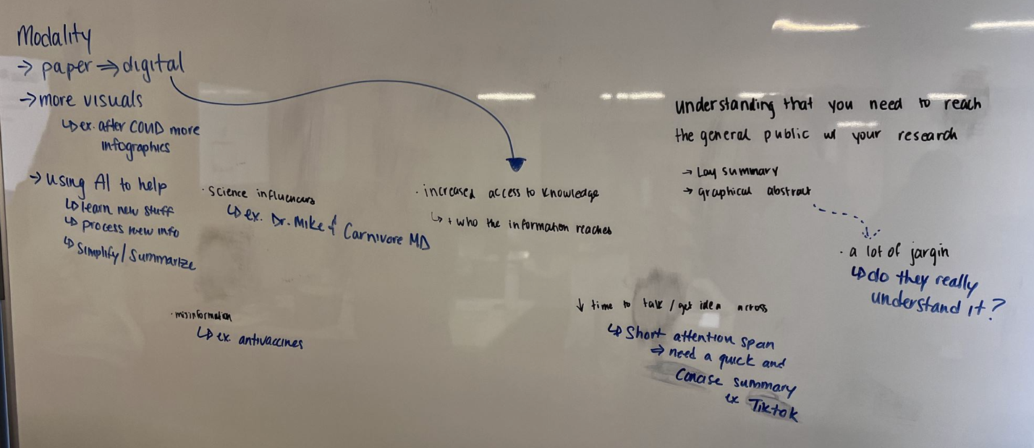

Class 2: Story Telling Narrative
Readings
How to tell compelling scientific stories:
Introduction
- Purpose of Communication: Researchers communicate their work not just to fulfill academic demands but because knowledge-building is a social and rhetorical act.
- Role of Genres: Effective communication in research writing and presentation is influenced by structure, purpose, audience, and occasion.
- Example: Communication varies based on context, such as a conference presentation versus an informal family gathering, highlighting the need for different genres of communication.

Writing Up
- Five Key Aspects:
  - Entering the Conversation: Write as if joining a conversation, focusing on the relevance of your research to a problem in the reader's world.
  - Mapping the Gap: Identify a problem, establish a gap in current knowledge, and articulate why this gap matters.
  - Telling the Story: Write persuasively, crafting a narrative that captures the reader's interest.
  - Crafting the Language: Use clear, engaging language to convey your research effectively.

Entering the Conversation
- Focus: Shift from describing the study to telling a story relevant to a problem in the reader's world.
- Journal Selection: Choose journals based on alignment with the problem your research addresses and their audience's values.
- Literature Review: Treat it as a map of conversational turns in the field, highlighting how your work contributes to ongoing discussions.

Mapping the Gap
- Three Steps:
  - Identify a Problem: Make it clear what problem in the world your research addresses.
  - Establish a Gap: Show where current knowledge or thinking about the problem is lacking.
  - Articulate a Hook: Convince readers that the gap you identified is significant and worth addressing.
- Context Sensitivity: Understand the evolving context of what constitutes a problem in your field to ensure relevance.

Practical Tips for Writing and Presentation
- Social Media: Utilize social media to disseminate research, reaching a broader audience beyond traditional academic channels.
- Imaginative Approach: Use metaphors like joining a cocktail party conversation to intuitively guide your writing and engagement with scholarly debates.

Key Principles Summarized
- Join a conversation: Position your research within ongoing scholarly discussions.
- Identify a problem: Make your research relevant to a real-world issue.
- Map the gap: Clearly outline where current understanding is lacking.
- Have a hook: Engage your audience by emphasizing the importance of the gap.
- Tell a story: Make your research narrative compelling and persuasive.
- Craft the language: Pay attention to how you phrase and present your findings.
It’s a story not a study:
- Include
  - clear question and propose a statement
  - theoretical framework
  - detailed methods and results
  - thoughtful limitations
- Key Differences Between Study and Story
  - Structural:
    - Study: Focuses on methods and results.
    - Story: Unfolds in the introduction and discussion/conclusion.
  - Rhetorical:
    - Study: Must be reported accurately.
    - Story: Must be told persuasively.
- Goals for Effective Research Papers
  - Understandable: The narrative should be clear.
  - Compelling: The story should engage the reader.
  - Memorable: The research should leave a lasting impression.
- Standard Manuscript
  - Introduction:
    - What problem did you explore?
    - What’s the hook—why does the problem matter?
  - Literature Review:
    - What conversation are you joining?
    - What’s the gap in knowledge?
  - Methods:
    - What did you do?
    - What was the rationale for the research design?
    - Is the explanation accessible?
  - Results:
    - Who are the main characters in your results?
    - Have you illustrated them convincingly?
  - Discussion:
    - How does your story add to the conversation?
    - How have you filled the gap?
    - How does the design limit your contribution?
  - Conclusions:
    - What’s the key lesson from your story?
    - What is the inevitable story-in-waiting?

The Science and Power of Storytelling
- Scientists need to engage and educate the public.
- Storytelling is a powerful tool for communication, enhancing understanding and inclusivity in science.
- Neural Mechanisms: Studying brain activation during story telling by Prof. Uri Hasson.
- Findings:
  - Listeners' brain activity aligns with the storytellers.
  - Similar neural responses across different languages show the narrative's power.
  - Shared interpretations lead to greater neural similarity.
- Storytelling in Science Communication
  - Brain Coupling: Listeners' brains sync with the storyteller’s, improving comprehension.
  - Implications: Storytelling can bridge divides by fostering shared understanding.
- The power of story telling
  - Engaging listeners creates a stronger and more meaningful transfer of the knowledge
    - creates intellectual investment and emotional bond between speaker and audience
  - Emphasizes the human side
  - Helps authors write engaging introductions
  - Connects science with cultural backgrounds
  - Use storytelling to empower
  - Makes science more inclusive and understandable
Making Science Meaningful for Board Audiences through Stories:
- Importance of Storytelling in Science Communication:
  - Stories help make science comprehensible and meaningful for general audiences by placing scientific information in a relatable and engaging context
  - Storytelling aids in the processing and recall of new information by audiences
- Challenges in Scientific Communication:
  - Scientists often struggle to convey the importance of their work to non-expert audience
  - There is a concern among scientists that storytelling might conflate empirical evidence with fiction, but effective storytelling in science involves highlighting the story elements inherent in the subject matter
- Elements of an Effective Story:
  - Protagonist: A relatable and often flawed main character that the audience can empathize with
  - Inciting Incident: An event that changes the protagonist's situation and sets the story in motion
  - Obstacles: Challenges the protagonist faces, which can be internal or external, adding depth and complexity to the story
  - Stakes: The risks involved if the protagonist fails, which keep the audience invested in the outcome
  - Broad theme: A universal lesson or message that resonates with the audience beyond the specifics of the story​
Science and Storytelling:
- Kids were able to visualize and understand the story
- Creating an emotional connection with the audience
- Going on the journey together
  - Shared experience
- Often there is a lack of relatability
- School science: Failure to anticipate
Lecture
Feedback on lay summary
- Give the global perspective as well as the local perspective
  - Ex. Hook: brain injury affects a people in the world
- Be precise and accurate… don’t leave anything unsaid
  - This tool could change how doctors understand life support treatment BY…
    - Improving, offering etc
- Open and close with a hook that will draw the reader
- Get a quote from researcher, carer or patient to show that you, as the reporter, have heard about it firsthand and to add a personal angle
- Balance essential detail with too much detail
  - But don’t be too vague as well
    - Ex …mislead factor => but what is the misleading factor, what do they mean by that?
- Don’t add too much science detail that will just make the piece difficult to read and understand
- Avoid word salas and check sentence meaning again
- Don’t start paragraph with this or it
Ask the author
- Target audience was vegetative state, students with some knowledge
- What’s something different you would do know that you published?
- How were you able to remember the facts and stuff, did you document your journey in a journal, and if not was it difficult to recall the memories and feelings you experienced
- How did you know you wanted to publish
- Did you know you always know you were going to write a book… because how were you able to recall the feelings, emptions, and experiences… did you document it?
What makes a good story?
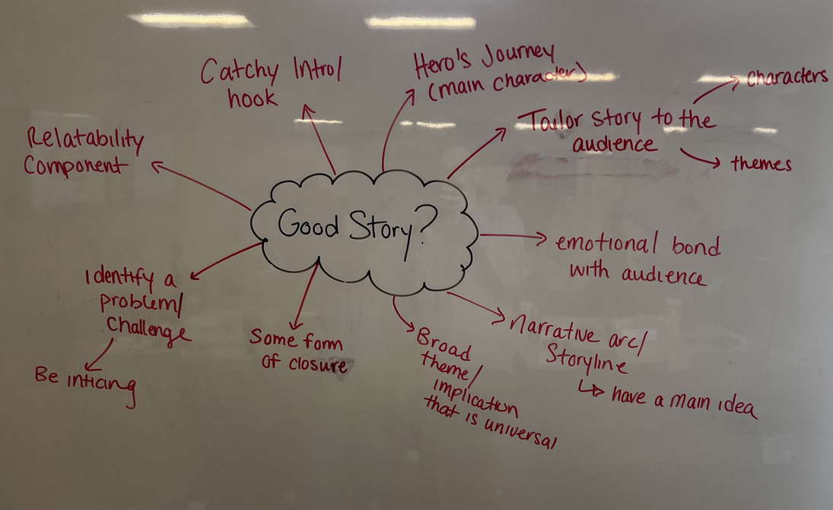

Class 3: Microteach presentation
Readings
Types of communication styles:
- Linear vs circular
- Direct vs indirect
- Low vs high context
- Attached vs detached
- Idea vs person focused
- Task vs relationship focused
- Formal vs informal
Active learning:
- Requires thoughtful engagement with course material
- Requires proper instructor design and guidance
- Incorporation into lecture
- Enhances deeper learning
- Evidence based approach
Lecture
Microteach Debrief
- Introduce yourself
  - Good habit to adopt
  - Be clear what the topic is about in the first 30 seconds
- Less is more
  - Can scale back
- Flow and order of information is important
  - Don’t want any confusion
- Filler words
  - Embrace the pause
  - Try to recognize and work on it

Class 4: Publications and Proposals
Readings
The Review process
- Manuscript submission review returned to editor reject/revise reject/ revise published
- Quality check, scope and see if it fits review
The Art of Grantsmanship
- It’s a competition
- To help optimize chances of success competing
- Good science can become non fundable grant proposal
  - Bad wiring will kill good ideas
- Proposal fits agency’s mission
  - Matching objectives
- Outline your proposal
- Keep proposal focuses, original, and feasible
Lecture
Paper vs Proposal
- Paper presenting result and how it fits into a question
  - Intro, methods, results, discussion
- Proposal request for approval, money, resources
  - Usually comes first
  - Tweak it to the agency
  - Objectives, preliminary data, background info
  - Why significance
  - Backup plans if experiment fails
  - Within the scope of the journal
  - Need a lit review
    - What do we know, what do we not know
  - Return on investment
    - Advance in society
    - Discoveries and impact to be made
  - Sex and gender analysis
  - Lay summary
  - Societal and scholarly benefits
  - Highly trained personnel and your credibility and CV on team
    - Why they are the perfect people to carry out research
  - Budget justification
    - Budget reflags
      - Not clear where money is going
      - Excessive with technology
      - Not allowed to pay yourself or people working for research, secretaries, admins
  - In kind costs
    - Arrangement to provide something that isn’t cash
    - Agency feels like you are getting a value for money and feel like you’re getting something for free
    - “Matching funds”
- Both are posing a research question
What comes to mind when you think of publication process
- Tedious
  - Focus is being pulled for professor
  - Getting all co-authors to agree
- Long
  - You vs the reviewers
  - About a year
    - Why?
      - Make changes if not approved right away
- Rewarding
- Tailored
  - Different journals have different requirements
- Impact factor
  - How much impactful the paper will have in the journal
Where to send it
- Fit in the journal’s scope
- Should aim high when submitting to journals
- H index
  - How many papers you published
  - Published high impact papers over a period of time
- Review journals have higher impact factor than peer review

Process (author, editor, review)
- Editor makes the decisions about the paper and not the reviewer
- Reviewer = just comment do not write if it gets published or not
  - 2/3 is standard
- Good editor will not go through a 3rd reviewer
Effective proposal
- Letter of intent
  - Pre submission inquiry
  - Saves time if you grant won’t get approved
  - A page long
  - Importance of the work
  - Tirage the grant
  - Used for budgeting
    - How much money is going to be asked

Grant panel review
- Tri council
  - Nserc
    - To advance knowledge in the natural science or engineering
  - Sshrc
    - To add to ours. Understanding and knowledge of individuals, groups societies
    - Lest largest budget
  - Cihr
    - All research primarily indented to improve health
    - Largest budget
- Under 4 you don’t get funded
- Score is how much money is left in the pot

Grant brief task
- SGBA
  - Look at tri council website
  - Training environment
    - Who you’ll train
    - EDI
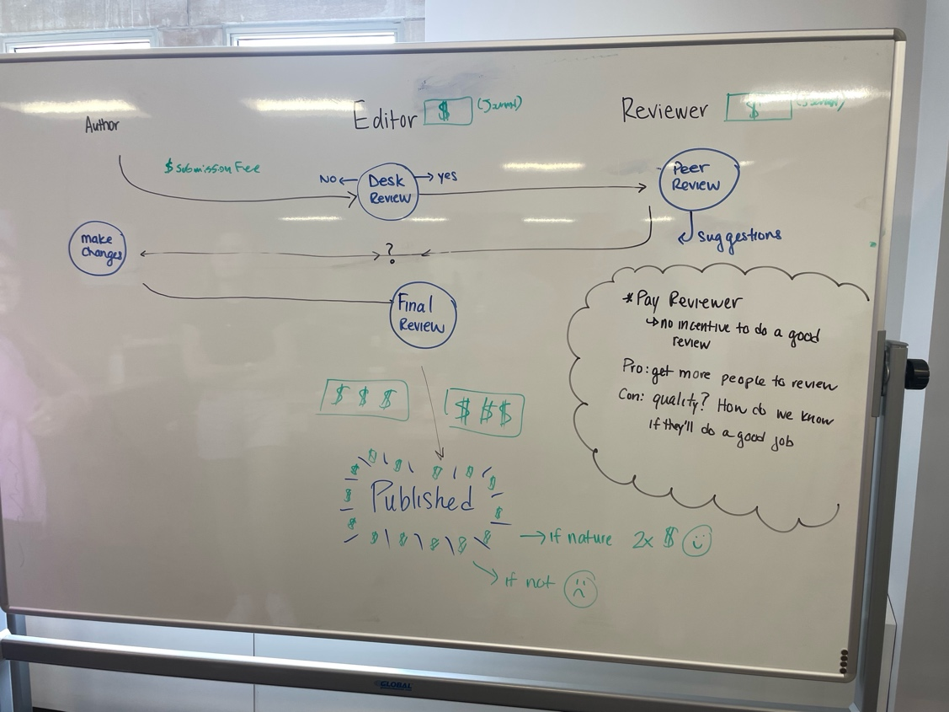
Class 5: Giving and Reading Feedback
Readings
Giving feedback on others’ writing
- Energy, clarity, persuasiveness
- Poor feedback can be confusing, unhelpful, and discouraging
- Feedback should be a conversation
- Being specific can help both the reader and writer
- If unsure where to start story, structure, then style
  - Way to organize feedback
- Too much feedback can be overwhelming
- Readers can sometimes offer generic comments if they don’t know how to address or name the problem
- Name problems know there is a problem but can’t say it? Just say that
- Resist urge to rewrite
- Find balance
- Feedback can be personal
Giving and Receiving Feedback
- Feedback is personalized information based on direct observation, aimed at helping receivers achieve their best potential
- Feedback should be specific, non-evaluative, and descriptive.
- It must be based on direct observation and relate to specific behaviors rather than personal traits.
- Effective feedback requires a respectful interpersonal climate and a committed relationship between giver and receive
- Giving feedback
  - Establish mutual learning goals that are specific, measurable, attainable, relevant, and time-bound (SMART).
  - Use constructive, descriptive, and non-judgmental language, focusing on behaviors rather than personal traits.
- Receiving feedback
  - Receiving feedback can be challenging and requires listening and active participation.
  - It is important to make conscious decisions regarding the implementation of feedback.
- Methods
  - Feedback Sandwich: Sandwiches negative feedback between positive feedback. Though simple, it can seem rigid or contrived.
  - Ask-Tell-Ask: A bidirectional method that involves asking for self-assessment, telling observations, and asking for understanding and action plans.
  - Pendleton Rules: Starts with self-assessment, followed by the supervisor's input on positives and areas for improvement.
  - 1-Minute Preceptor: Incorporates feedback into brief teaching moments, focusing on specific learner behaviors and understanding.
- Barriers
  - Mismatched perceptions between givers and receivers about the amount and quality of feedback.
  - Lack of established feedback relationships and clear expectations.
- Strategies
  - Label feedback conversations explicitly.
  - Foster trusting relationships and create opportunities for continuous feedback.

Lecture
Publication Ethics
- Authorship scenario
  - Didn’t really work on the manuscript
  - If they have a job for the task they don’t need to be considered as an author
    - Didn’t really contribute to the science
    - They were paid to do the science
  - Takes away from the people who are actually doing the science
  - Have an acknowledgement section
  - The student can also ask if they are going to or not going to be an author, what they can do to be a doctor
  - Substantial contribution, drafting and reviewing, final approval, accountability
- Corresponding authorship
- First author person who thought of it and did the work
- End author lab chief, PI, senior person
- Coauthorship equal contribution
- In education field often PI is first
  - Order of contribution
Feedback
- Is information provided regarding aspects of ones performance or understanding
- Serves the purpose of improving future actions and behavior by highlighting areas of strength and identifying opportunities for growth
- For
- Important because
  - Always learning
  - Only as good as your feedback
  - Cohesiveness and same understanding
  - Furthering innovation inspiring people/ ideas
  - Preventing mistakes
  - Maintaining creditability
- Ex.
  - Publication process constant edits
  - Lay summary review readability
  - For evaluation or review
  - Patient
    - Surveys
    - Regular conversation
  - Lab
    - New technique, or equipment
  - Teaching
  - Peer feedback

Types of feedback
- Constructive criticism
- Positive feedback
- Negative feedback
- Where?
  - Employment
  - Sports
  - Teaching position
  - Social media
What comes to mind when you think about feedback
- Growth get better at everything
- Learning
- Self-reflection
- Noise sometimes people miss the point
- Focused feedback get back more details
- Context providing context, provide the knowledge prior

Effective Feedback
- Specific clear and concise
- Actionable
- Timing
- Nonjudgemental be objective
  - Offers a new voice
- Honest and genuine
  - Transparent from where your feedback is coming from
  - Framing it by saying “if I were to do it..”
- Bidirectional have a conversation
  - Ongoing
  - Not just a one way evaluation
- Balanced better word would be respectful
  - Linked to genuine and real
  - Poke holes so that it can be better
- Focused on behaviour not personal, or attack person
Peer review
- Letter
- How would you format and structure it?
  - Sandwich method
  - Can be personal and informal
  - Overarching statement and specific statements
    - Overall and circle back
  - Summary and contextualize
  - Single spaced
  - Address and sign name at bottom
  - 3 sections, intro body and conclusion
  - Different components and have subheadings
    - Themes or sections
  - Provide your justification why you are bringing awareness to a particular form
  - Opinion based
    - Statements more than questions
Response letter
- Something you justify
- Respond to the points
  - Thank you for bringing this into consideration
  - Acknowledge and appreciate
  - Perhaps a misunderstanding
  - No, I don’t agree because
Class 6: Mock Interview
- Just prepped for interview! No readings or notes
Interview
- Themes
  - Career in science
  - Personal
    - Who is Dr. Owen
    - Things that happened that led to his journey in this career
    - Who is …
      - Why did you choose neuroscience
      - How was you’re experience during your academia career
      - What made you who you are
  - Advice for upcoming scientists
    - Ethics
    - Publications
    - What are some lessons in science communication that you learned that you could share with the listeners?
  - Journey of writing into the gray zone
    - What’s the experience like
    - How would you change, or would you change something if you had the chance to go back
    - What lesson learned that you’ll implement into future books
    - Storytelling
    - Who came up with the title and what made the think of it
    - What was the editing process like
    - How were you able to remember everything? Did you write everything
    - Emotional component?
- Publications
- Podcast has a theme
- Welcome to blah blah blah podcast we will be exploring
- Conversational style
  - Avoid each person asking questions

Class 7: Open Science
Readings
Predatory journals:
- Global threat, accepting articles without quality checks for issues like plagiarism or ethical approval in exchange for fees.
- They confuse readers, waste resources, and publish shoddy scholarship
- no universally accepted definition of predatory journals, making it hard to address the issue
- Predatory journals (PFJs) publish articles without proper editorial and peer review processes, focusing on profit rather than scientific quality.
- These journals often provide false information, such as fake impact factors and editor credentials.
- Consensus definition
  - Predatory journals and publishers are entities that prioritize self-interest at the expense of scholarship and are characterized by false or misleading information, deviation from best editorial and publication practices, a lack of transparency, and/or the use of aggressive and indiscriminate solicitation practices.
- Characteristics
  - False and mislead information
  - Deviating from best practices
  - Lack of transparency
  - Aggressive solicitation
  - Harm in scientific integrity
    - Publishing low quality research
- Quality of peer review and the intent to deceive were deliberately left out due to the difficulty in assessment and subjectivity
- Developing a portal with educational resources and establishing an international observatory to track the problem.
- Collaborating with funders, institutions, and other stakeholders to develop resources for assessing journal quality.
- Located in developing countries
  - Possible due to limited access to reputable journals
- Reasons for publishing
  - Rapid academic promotion
  - Publish or perish culture
  - Unaware of the nature of predatory journals

Lecture
Publication process
- Subscription based gets paid/ no need to pay
- Open accesses have to pay
- Predatory only people benefitting is them
- APC = Article processing charge
Decision process
- Where do I see this work fitting in
- Beales list
Open accesses
- What is it?
- What does it mean
- Pre registration register your idea so that someone around the world does
  - But nothing stopping someone taking the idea and running the experiment
  - State what p test your going to use and what tools
- P hacking
  - Running p values to find a significant p vale
- Open education
- Best open practice Computer science (sharing and making it better)
  - Physics
  - AI
- Open: freely available for readers , transparency
- Downside
  - Very expensive (especially fees)
  - Making publishing houses incredibly rich
Predatory journal
- Predatory publisher deceiving the author
  - Company
- Predatory journals
  - Affiliated with the publisher
- Hijacked journals
  - Brandjacking
  - Taken over by bad influence
  - Disguise themselves
  - People are onto predatory publishers
- Why do people cite retracted journals
  - Not going back to the source
    - By citing when not acc reading the paper
Preprint publications
- Differences between peer review and preprint
  - Preprint
    - Open accesses
    - Accelerate progress
    - Immediate access
    - More eyes on it
    - Keep up to date of progress
    - Valuable feedback
  - Peer review
    - Peer review cycle
- Connection to scientific community and media
- Because its easy to publish a pre print does that mean anyone with a paper can submit a preprint? What’s stopping people from uploading a bunch of papers one of the disadvantages of preprint
- Upload as preprint but doesn’t get published journal rejected and cant find a home for the paper
- But negative findings as a preprint
Stages of writing
- Free writing write without thinking about grammar
- Organizing review and highlight interesting ideas
- Drafting creating a basic structure
- Reviewing exchange draft with partner and not areas that are unclear
- Revising take feedback and revise
- Editing correct grammar, spelling, punctuation
- Sharing --. share final work and discuss

Class 8: Debate & Debrief
- Just prepped for interview! No readings or notes

