MEDSCI 9507
Learning log

Class 1: Introduction to EDI
January 6, 2025

Presession Task
• Diversity and Innovation:
- Diversity drives excellence and enhances innovation in biomedical science and clinical practice.
- Diverse teams produce better research outcomes, such as higher citation rates and novel insights.
- Teams with complementary skills address health disparities and create meaningful solutions.
• Benefits of Diversity:
- Encourages different perspectives, improving problem-solving and decision-making.
- Intersectionality enriches research by incorporating complex, interconnected identities.
- Diverse groups are better equipped to tackle health disparities in underserved populations.
• Barriers to Diversity:
- Educational Pipeline:
  - Underrepresented groups face limited access to resources and support.
  - Imposter syndrome and stereotype threats affect performance and confidence.
  - Bias in admissions and curricula disadvantages students from minority backgrounds.
- Unconscious Bias:
  - Affects recruitment, evaluation, and promotion.
  - Evident in gender disparities in hiring and funding decisions.
- Systemic Inequities:
  - Salary discrepancies based on gender, race, and intersectional identities.
  - Underrepresentation of women and minorities in academic leadership.
• Strategies to Foster Diversity:
- Individual Efforts:
  - Mentorship, promoting underrepresented voices, and checking personal biases.
- Institutional Efforts:
  - Pipeline programs, mentoring networks, and unconscious bias training.
  - Transparent diversity metrics, inclusive policies, and family support initiatives.
  - Credit for institutional service and language/writing support for non-native speakers.
- Educational Reforms:
  - Updated medical curricula to address historical racism and social determinants of health.
  - Training programs focused on LGBTQ and minority populations.
• Call to Action:
- Medical research and education must parse genetic factors from social determinants.
- Institutions must periodically reassess and report on diversity initiatives.
- Zero tolerance for harassment and discrimination, with clear accountability mechanisms.

Lecture Notes
Defintions
- Equity
  - means fairness. It is the removal of systemic barriers and biases enabling all individuals to have equal access to and to benefit from any aspect of society
- Diversity
  - is defined as differences in race, color, place of origin, religion, immigrant and newcomer status, ethnic origin, ability, sex, sexual orientation, gender identity, gender expression, age, and others. It consists of the conditions, expressions, and experiences of different groups
- Inclusion
  - is the practice of creating an environment that ensures all individuals are respected equitably and have access to the same opportunities.
- Intersectionality
  - an approach that considers the differences in power relationships for individuals from different marginalized groups and ensuring that these are accounted for when strategizing about EDI
- allyship
  - any person that actively promotes and aspires to advance the culture of inclusion through intentional, positive and conscious efforts that benefit people as a whole.
- Uncounsious bias
  - is an implicit attitude, stereotype, motivation, or assumption that can occur without one's knowledge, control, or intention. It is a result of one's life experiences and affects all types of people.
- Reform
  - the process of constantly renegotiating and restructuring standards to reflect the ever-evolving contemporary ideals of social, economic, and political culture
- Justice
  - based on the concepts of human rights and equality, and can be defined as "the way in which human rights are manifested in the everyday lives of people at every level of society. The distribution of wealth, opportunities, and privileges within a society.
- Privilege
  - refers to certain social advantages, benefits, or degrees of prestige and respect that an individual has by virtue of belonging to certain social identity groups. Within American and other Western societies, these privileged social identities—of people who have historically occupied positions of dominance over other

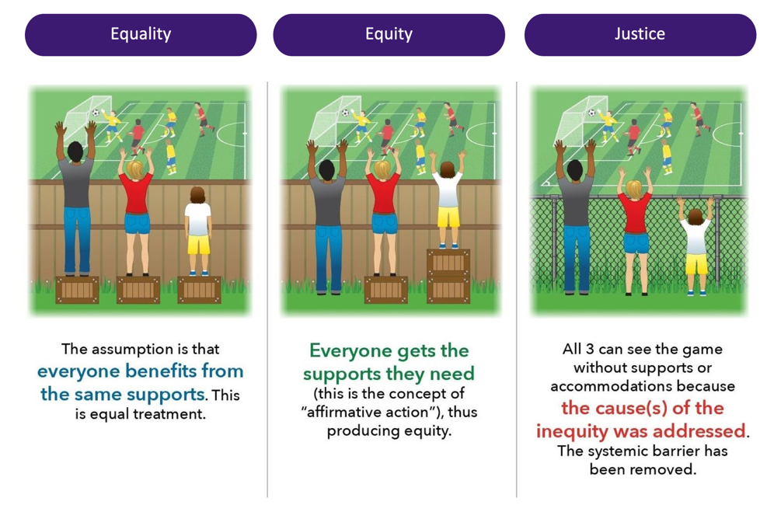
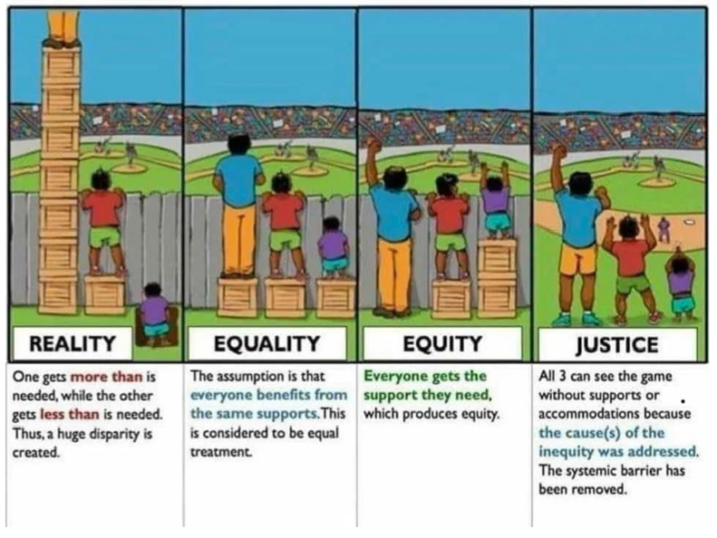

EDI in Research
- EDI is the understanding and acknowledgment that:
  - Historical inequality has led to current cultural inequit
  - Diversity through intersectional considerations is a necessary component of research success
  - Inclusive praxis will benefit all in the Canadian and global research environment.
Why do we need to consider EDI in research
- When we appreciate diversity
- Innovation and quality
- Ideas and creativity
- Perspective and critical analysis

Why is diversity beneficial to science
- People bring different perspectives
- 1.2 million US PhD recipients from 1977-2015
- Underrepresented groups produce higher rates of scientific novelty
- However, their novel contributions are devalued and discounted
  - E.g. novel contributions by gender and racial minorities are taken up by other scholars at lower rates than novel contributions by gender and racial majorities
  - Equally impactful contributions of gender and racial minorities are less likely to result in successful scientific careers than for majority groups.
- The discounting of minority innovations may partly explain their underrepresentation in influential positions of academia

Is EDI well defined in academic insitituion
- We are getting there
- Institution has a campus wide definition for EDI (55% 88%, from 20192022)
- Insisituions has an EDI action plan ( 70% 83%)
Diversity, equity, inclusion and belonging at organizations
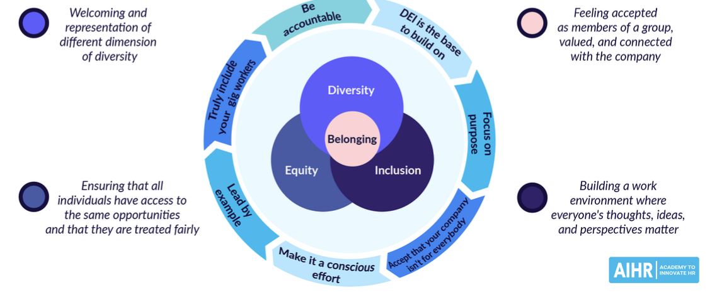

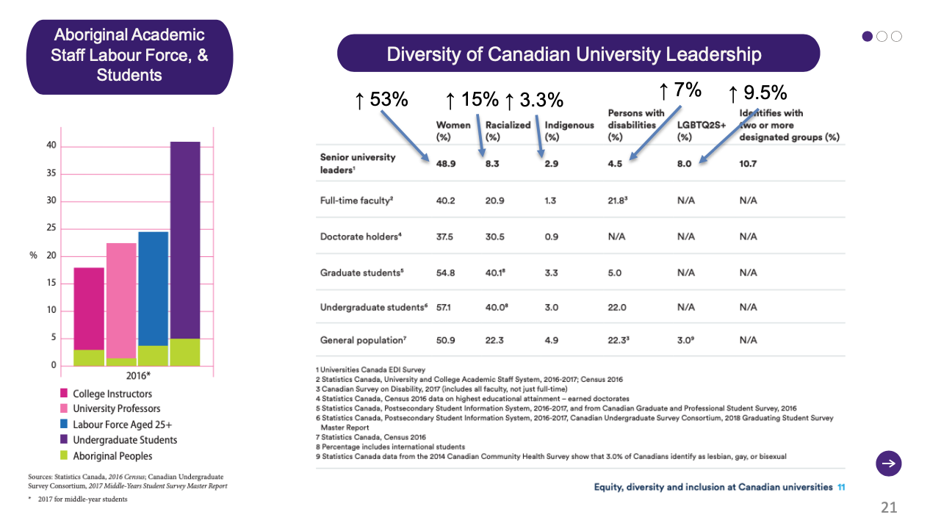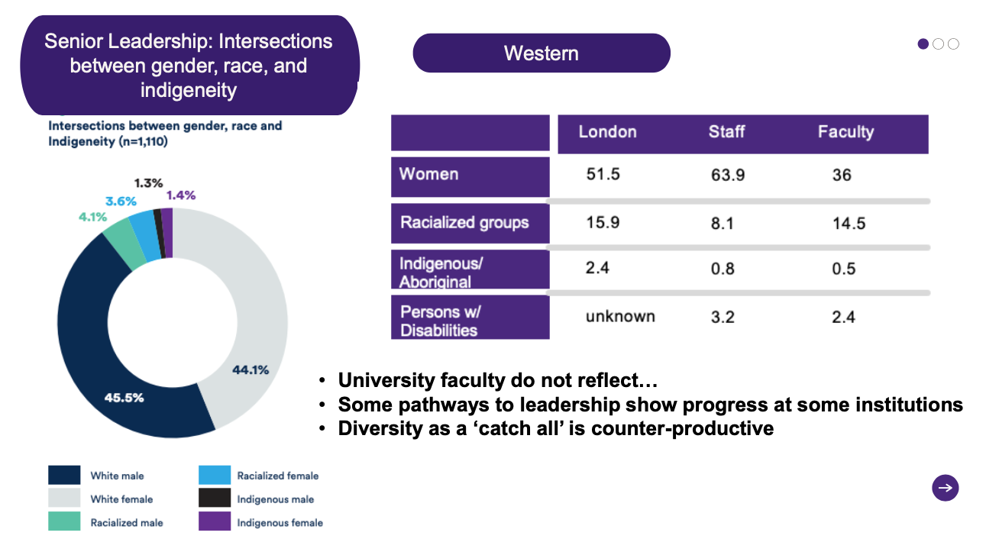

EDI Frameworks
- Human rights
  - Compliant based system intented to reinforce anti discrimination and anti harassement laws
  - Based on a conflict managamnet model, this approach details the procedures that will be employed to address harassement
  - Problem with this framework?
    - individual rights – individual
    - Separates the individual from historical or societal contexts
    - obscures the ways in which discrimination and harassment are structurally reproduced in society
    - addresses some forms of discrimination more easily than
    - others
- Diveierty
  - Encourages people to welcome and respect those who are different
  - Aim to increase the number of indvividuals with particular social identities and backgorus, very often with a strong focus on gender, race, and ethnicity
  - Problems with this framwork
    - Ignore social and professional inequities
    - no commitments to address the issues related to hierarchical social structure
    - historically excluded individuals are simply invited into the systems that have alienated them
    - increase the number of observable differences without having to make institutional commitments to overcome systemic inequities
EDI frameworks – equity
- society has historically included and privileged some groups while simultaneously marginalizing others
- Acknowledge the impacts that historical (and ongoing) inclusions and exclusions have had on different groups of people and commit to personal and institutional changes aimed at creating an equitable community.
- Why is this approach necessary?
  - meaningful and affirming opportunities for groups
  - must address the structural causes of exclusion that stem from interrelated factors such as racism, sexism, ableism, settler colonialism, and the notion that Western values are superior to other life conceptions.
  - a way of thinking through the various ways these and other factors intersect
    - how these different intersections privilege some groups over others
  - An intersectional approach to EDI with the understanding that race, class, gender, sexuality, (dis)ability, nationality, religion, language, and age interact in ways that can increase or decrease opportunities for both personal and professional development.
- 3 steps
  - Acknowledge and Identify Ongoing Inequities
  - Commit to a Set of Overarching Principles
  - Take Action within Your Sphere of Influence Step

Canada Research Chairs Program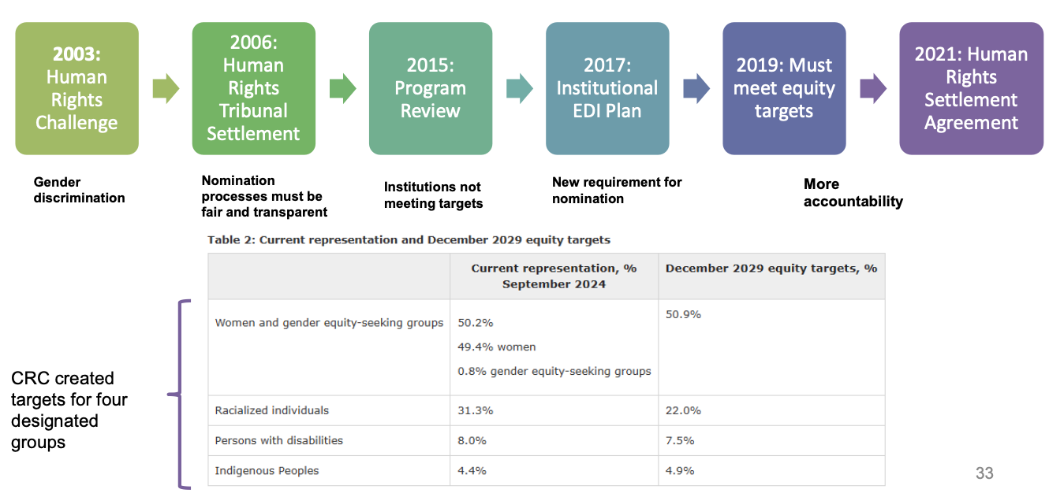

Tri agencies
- The Tri-agency is acting on the evidence that achieving a more equitable, diverse and inclusive Canadian research enterprise is essential to creating the excellent, innovative and impactful research necessary to advance knowledge and understanding, and to respond to local, national and global challenges. This principle informs the commitments described in the Tri-agency statement on equity, diversity and inclusion (EDI).

General tmeline of EDI in research and academic careers
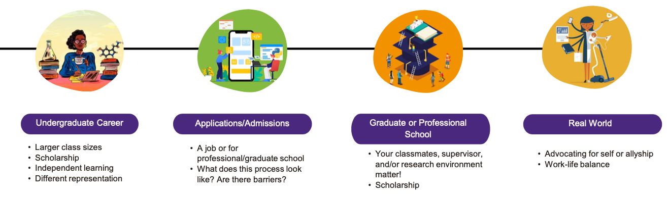

How to incorporate EDI in research?
- EDI principles should be incorporated into interactions especially within research environments and among peers/colleagues
  - Demonstrate allyship
  - Remain knowledgeable about societal influences on research spaces
- Strategies should be developed to ensure EDI excellence
- Relate these EDI strategies to the research itself
  - Data collection
  - Diverse perspectives in qualitative and quantitative work
- Incorporate advocacy
  - Identify and remove potential barriers in research
  - Include EDI support into the project/program structure and budget
- Look, think, reflect, be intentional
- Create a meaningful EDI vision/mission statement for your research program.
- Surround yourself with diverse perspectives
- Learn! EDI Education and Training - YOU'RE DOING THIS RIGHT NOW!
- Challenge the culture and structures in your research area
  - Build your own positive spaces and environments – is there anything that exists to support you and others?
- Mentorship and professional development
- Community engagement/outreach
- Research design and data analysis
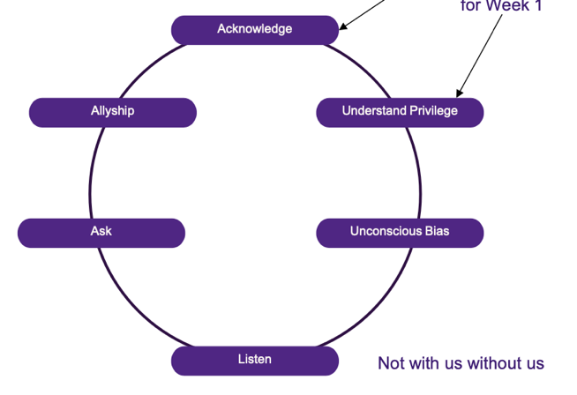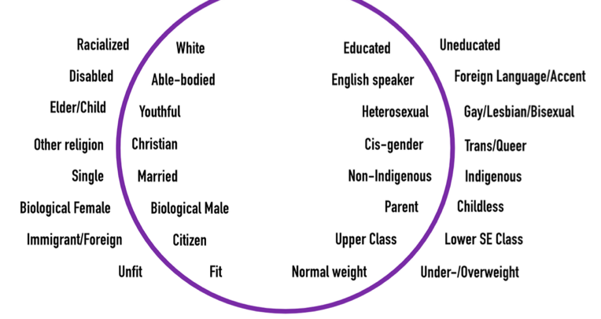

Where does this leave us as we move through research?
- Nevere with us without us – consultation of research with groups
- Mentorship and who has access to research teams and mentors
- The system in place often oppress or favour the success of certain individuals
- Success is often defined by longstanding and outdated metrics, so you’ll need to be stragteic

Dynamic between mentors and mentees
- What mentees expect
  - Guidance, help, repesct
    - Provide guidance, which means something different for everyone
    - Help the student prepare for the culminating activity in the program (e.g. thesis defense)
    - Demonstrate respect for the student, which also means something different for everyone
- What mentors expect
  - Projects, career path, feedback, communicate
    - Do part of at least one of the supervisor's research projects
    - Timely completion
    - Forge a career path that at least starts out resembling their own
    - Accept feedback willingly & put it into action
    - Communicate any difficulties, questions, or objections directly, timely, & respectfully
    - Demonstrate writing & research that match their grad school application package

Developing a positive relationship with a mentor
- Clear and frequent communication
- Self awareness
- Seek help

Class 2:
January 8, 2025

Presession tasks

Canada’s shameful history of nutrition research on residential school children: The need for strong medical ethics in Aboriginal health research
History of Medical Ethics:
- Medical ethics has a shorter formal history compared to science and research.
- Origin tied to WWII Nazi atrocities leading to the Nuremberg Code of Medical Ethics (1946).
- 20 Nazi doctors were tried in Nuremberg for violating the Hippocratic Oath.
Unethical Nutrition Experiments on Aboriginal Children:
- Conducted in Canada (1942–1952) by the Department of Indian Affairs.
- Led by Dr. Percy Moore and Dr. Frederick Tisdall, noted Canadian physicians.
- Experiments lacked parental consent and continued despite child deaths.
- Involved:
  - Malnourished children in residential schools.
  - Control and treatment groups receiving inadequate nutrition or supplements.
  - Supplements failed to mitigate malnutrition effects, and children became more anemic.
  - Dental care deliberately withheld for observation purposes.
Parallels with Tuskegee Syphilis Study:
- Tuskegee (1932–1972): Study on untreated syphilis among Black men in Alabama.
- Both studies targeted already marginalized and vulnerable groups.
- Research subjects lacked advocates and were exposed to harm without consent.
Lessons and Ethical Considerations:
- Ethical health research has improved since the 1940s.
- Aboriginal children remain a vulnerable population requiring extra care.
- Recommendations from Canadian Paediatric Society:
  - Aboriginal community ownership of research projects.
  - Data safety review committees.
  - Rigorous research ethics board reviews.
Call to Action:
- Healthcare providers must remain vigilant to minimize research abuse.
- Ethical oversight, introspection, and accountability are critical.

Recalibrating the Use of Race in Medical Research

Historical Context of Race in Medicine
- Introduction of Race in Medical Curricula:
  - Introduced in 1790 by Benjamin Rush, who falsely equated blackness with leprosy.
  - In 1857, Josh Nott characterized slaves as biologically suited for hard labor.
  - Jim Crow era (1870s) reinforced segregation in medicine and societal exclusion.
- Legacy: This history forms the basis for race’s use in medical research.

Race as a Variable in Medical Research
- Challenges:
  - Race is a socially constructed, imprecise, and non-biological variable.
  - The Human Genome Project (1999) found no genetic basis for race.
- Critique:
  - Differences in research studies attributed to "race" often stem from racism and systemic inequalities.
  - Race is a poor surrogate for biology and an imprecise measure of social constructs.

Modern Issues and the Call for Change
- COVID-19 Impact:
  - Exposed how racism perpetuates health inequities.
  - The use of race in research often masks racism rather than addressing it.
- Questions Raised:
  - Should race variables be eliminated entirely?
  - Are there better alternatives for capturing sociological and biological factors?
- Moral Imperative:
  - Eradicating racism in medicine and research is essential.

Schools of Thought on Race in Research
- Improvement of Race Variables:
  - Strengthen measurement, analysis, and reporting (e.g., self-identification in trials).
  - Challenges:
    - Race data is often fragmented, inconsistent, and poorly utilized.
  - Vast medical literature exists but is often uninformative.
  - Few studies conduct meaningful race-based subgroup analyses.
- Elimination of Race Variables:
  - Race as a measure is a painful relic and should be replaced by more robust variables:
    - Biological constructs (e.g., genetic ancestry).
    - Sociological constructs (e.g., discrimination, socioeconomic status).
  - Issues with genetics:
    - Overrepresentation of European ancestry in genomic data (88% as of 2018).
    - Limited practical utility in improving health equity.

Sociological Constructs and Alternatives
- Sociological variables like social determinants of health, access to care, and financial mobility may better capture disparities.
- Limitations:
  - Nonstandardized, crudely measured, and incomplete in explaining differences attributed to race.

A Middle Ground: Improvement vs. Elimination
- Past Research:
  - Reevaluate race variables in established knowledge (e.g., clinical algorithms, treatment effects).
  - Determine if race remains relevant or should be replaced by better measures.
- Future Research:
  - Systematically review prior research to avoid redundancy or extract insights.
  - Consider collateral variables for standardization and accuracy.
  - Avoid defaulting to White race as a reference standard.
  - Assess clinical and social consequences of race-related research to minimize inequality.

Recommendations for Moving Forward
- Four Steps for Future Research:
  - Systematic review of prior studies involving race.
  - Inclusion of explanatory biological and sociological variables.
  - Avoiding problematic racial references (e.g., White as a default norm).
  - Holistic evaluation of race-related research impact on equity and inequality.

Lecture notes
Race in healthcare
Race - a social construct; biologically meaningless when applied to humans – physical differences such as skin color or facial features have no natural association with group differences in ability or behavior
Ethnicity - perceived common ancestry, history, and cultural practices, which are seen as more fluid and self-asserted rather than assigned by others
Identities - social and personal, including but not limited to race, gender, gender expression, sex, sexual orientation, religion, ethnicity, socioeconomic class, and physical and mental abilities.
Race is embedded in how scientists and clinicians conduct research, predominantly based on:
- How we define it
- Who defines it
- Emphasizing race in clinical decision-making and scientific conclusions profoundly influences medical practice and research design, often shaping approaches to diagnosis, treatment, and study outcomes.
To identify, monitor and address inequities that potentially stem
from bias and racism — including at systemic, interpersonal and internal levels
Races are distinguished by perceived common physical characteristics, which are thought to be fixed,
- whereas ethnicities are defined by perceived common ancestry, history, and cultural practices, which are seen as more fluid and self-asserted rather than assigned by others
- Internalized racism lies within individuals. This type of racism comprises our private beliefs and biases about race and racism, influenced by our culture. This can take many different forms including: prejudice towards others of a different race;
- internalized oppression—the negative beliefs about oneself by people of color; or internalized privilege—beliefs about superiority or entitlement by white people. Interpersonal racism (personally mediated) occurs between individuals. This is the bias that occurs when individuals interact with others and their personal racial beliefs affect their public interactions.
- Institutional racism occurs within institutions and systems of power. This refers to the unfair policies and discriminatory practices of particular institutions (schools, workplaces, etc.) that routinely produce racially inequitable outcomes for people of color and advantages for white people. Individuals within institutions take on the power of the institution when they reinforce racial inequities.
- Structural racism is racial bias among institutions and across society. This involves the cumulative and compounding effects of an array of societal factors, including the history, culture, ideology and interactions of institutions and policies that systematically privilege white people and disadvantage people of color.
Genetics research has shown that people are about 99.9% genetically similar and that there is more genetic similarity across socially constructed racialized groups than within them.31, 32 Research has shown that disease risk — often associated with race — is in fact driven by geographic origin and environmental selection pressures.33
- For example, sickle cell anemia is commonly thought of as a condition that affects Black populations.34 However, it is not being Black that puts a person at risk of the disease, but whether their ancestry is from a malaria-endemic region of the world.35 Consequently, multiple populations — including some West African, Middle Eastern, Mediterranean and Asian populations — are at increased risk of sickle cell anemia.36
- - enterprise of eugenics—improving the genetic quality of white, European races by removing people deemed inferior—gained massive popularity, with advocates on both sides of the Atlantic. It would take the Holocaust to show the world the logical endpoint of such horrific ideology
- white persons viewed black persons, latinX, and Asians more negatively than themselves, but black persons were viewed more negatively than all other groups, and latinX twice as negatively as Asians
Assumptions impact research
Case 1:
ASCVD (Atherosclerotic Cardiovascular Disease) 2013 Risk Calculator from AHA/ACC
Uses:
- Age, diabetes, sex, cholesterol, blood pressure, smoking history, race (3 categories)
- SCENARIO: A 40-year-old White male smoker has a lower cardiovascular risk than a 40-year-old Black male non-smoker

Case 2
Glomerular Filtration Rate Calculator
- Best overall index of kidney function. Normal GFR varies according to age, sex, and body size, and declines with age.
- SCENARIO: A higher GFR (i.e., better kidney function) is assigned to Black patients with the same creatinine value as people of other races.
Case 3
Vaginal Birth After Cesarean (VBAC) Calculator
- Best overall index of kidney function. Normal GFR varies according to age, sex, and body size, and declines with age.
- SCENARIO: The likelihood of a successful vaginal birth after cesarean delivery (VBAC) is assigned as a lower chance of VBAC success for Black women compared with White or non-Black Hispanic patients.
Without considering lifestyle, drug use, or the significant heterogeneity in the Black population, this decision-making tool lumps all Black people together and determines that being a Black man is more dangerous than smoking.
Inflating GFR in Black patients leads to underdiagnosis of chronic kidney disease in this population and makes it less likely that they will be referred to a nephrologist or become eligible for kidney transplantation. Additionally, the erroneous beliefs about lower effectiveness of ACE inhibitors in Black patients mentioned earlier can prevent those with chronic kidney disease from receiving one of the key medications that can stop disease progression.
Black patients have significantly higher maternal morbidity and mortality
Instead of encouraging a mode of delivery that can improve recovery time and lower the risk of infection or postpartum hemorrhage, this calculator potentially discourages maternity care clinicians from offering Black patients a trial of labor after a cesarean delivery. Instead of treating these patients as a homogeneous group, we should be aggressively studying the social and systemic factors that have historically resulted in more cesarean deliveries.

The history
- Where did we get the idea that “race” correlated with biology or genetics?
- What is the origin of beliefs about larger muscle mass and smaller lung capacity?
As early as Thomas Jefferson’s Notes on the State of Virginia, in which he remarked on the dysfunction of the “pulmonary apparatus” of Black people, lungs were used as a marker of difference, a sign that Black bodies were fit for the field and little else. (Forced labor was seen as a way to “vitalize the blood” of flawed Black physiology. By this logic, slavery is what kept Black bodies alive.) • First – you have to build in the assumption that there are 2 or more distinct categories of human – white and Black (and Asian and Native etc.). • Second, that the categories are distinct and well-defined and biologically meaningful.
Jefferson’s proclamation, of deficient pulmonary functions in black people, was used to justify slavery, believing that forced labor was a way to “vitalize the blood” of deficient black slaves (1). By President Jefferson’s logic, slavery was what kept black individuals alive.
- Dates even further back
  - Phrenology was one example of this – the belief popular in 19th-century Europe and America that character traits could be read through differently shaped skulls. The idea that Black people were naturally submissive was used by some slave owners to justify their trade.
President Thomas Jefferson a difference in pulmonary structure b/w slaves & colonists
1864, Benjamin Gould conducted an immense and, to this day, influential survey of black and white soldiers at the end of the Civil War
  - “Full blacks” had lower lung capacity than “whites.”
  - No adjustment for height, age, or attention to working and living conditions of newly emancipated slaves
Justified by using the work of Adair Crawford, a chemist and physician. In his influential 1779 book, Experiments and Observations on Animal Heat, Crawford discussed experiments on respiratory gas exchange in animals
- critical consideration, because numerous studies document that people living around high-pollution areas have lower lung capacity.
- High-pollution areas also correlate with minority status
Why is this problematic?
- used to promote racism
- pulmonary function continued and supported innate differences with whites having a higher lung capacity than blacks, Chinese, or Indians
- diverts attention and resources from many social determinants, including the lack of access to high-quality medical care; food deserts in poor neighborhoods; exposure to environmental toxins; high rates of incarceration; and experiencing the stress of racial discrimination
Racial discrimination and adverse birth otucomes
Racial and ethnic minority women experience higher lifetime exposure to chronic stressors, which may increase their risk for poor pregnancy outcomes
- The infant mortality rate (IMR) for Black infants remains more than double that of White infants. Recent data indicates a rate of 10.9 deaths per 1,000 live births for Black infants, compared to 4.5 for White infants.
- Black Women: The preterm birth rate among Black women is approximately 1.5 times higher than that of White women. In 2022, 14.6% of infants born to Black women were preterm, compared to 9.4% for White women.
    - Preterm birth–related IMR is 3x higher in black women compared to white women
Between 1845 and 1849, J. Marion Sims, considered the father of gynecology, experimented and operated on Black women with no anesthesia, as it was widely believed that Black people didn't experience pain the same as white people did.
Infant mortality rate ne of the most important indicators of the health of a nation as it encompasses several health indicators such as maternal health, access to health care, and public health practices
- Understanding the research
  - qualitative studies, participants provided support for racial discrimination as a risk factor for adverse birth outcomes
  - Participants described experiencing institutional racism in receiving prenatal care and seeking employment,²² racial discrimination during childhood having lasting health effects,²⁴ and how the stress associated with racial discrimination could be a risk factor for preterm birth.
  - Ex. tobacco use was a significant predictor of birth weight, while racial discrimination wasn’t a significant predictor in the final model. It could be hypothesized that tobacco use is a coping mechanism used to deal with the stress of racial discrimination and may well function as a mediator in the racial discrimination-adverse birth outcome association.
  - Racial discrimination is likely to date back to a woman’s childhood and likely to previous generations important to consider lifetime racial discrimination
  - State-level funding policies in areas of health care, education, and employment, combined with systemic racism, may be one pathway by which structural racism at the state level and income inequality contribute to disparities in birth outcomes
Not limited to the US, yet less extreme in Canada
- https://www.cmaj.ca/content/cmaj/188/1/E19.full.pdf
- Preterm birth rates among black women in Canada were 8.9%, compared with 5.9% among white women.
- In Canada, 4.2% of all births were to women who self-identified as black compared with 20.5% in the US.
A timeline
Racial Difference: 19th Century - Phrenology, 1861: race corrected spirometers for lung capacity
Deception & Misinformation: 1932, Tuskegee experiment 600 poor Black men in Alabama for a syphilis study. “Free Blood Test; Free Treatment” said the advert. 399 in the group who had syphilis were never treated – they were just observed until they died.
Without consent: 1951, Henrietta Lacks, “HeLa” cell line used for medical breakthroughs like including the polio vaccine, cancer treatments and IVF.
Digital Discrimination: In 2019, an algorithm that helps manage healthcare for 200 million people in the US was found to systematically discriminate against Black people with allocated lower risk scores by the computer than white counterparts, leading to fewer referrals for medical care
Racism has been perpetuated under the guise of science going back centuries, notably by 18th-century Swedish botanist Carl Linnaeus, the godfather of taxonomy, and Samuel George Morton, a 19th-century American doctor and anatomy professor who documented the supposed differences between Indigenous people and Europeans by looking at their skulls.
In other parts of the world:
Japan - The Japanese army established several biological warfare programmes throughout China and Singapore.
- - 1932 and 1945, Japanese doctors did many vivisections and barbarous experiments. Their purpose was to develop effective weapons for biological warfare, although their objectives were wider than this. Their human experiments included vivisections of healthy men and women; intentionally infecting healthy men and women with diseases such as plague, anthrax, cholera, and typhoid;
1996 Pfizer sent a team to Kano in the north of Nigeria during an epidemic of meningococcal meningitis. To test the efficacy of its new antibiotic trovafloxacin (Trovan) they carried out an open label trial in 200 children, half of whom were given trovafloxacin and half the gold standard treatment for meningitis, ceftriaxone. Five of the children given trovafloxacin died, together with six who were given ceftriaxone. Pfizer said that 15000 people died during the epidemic
Racial Difference: 1962: geneticist James V. Neel formulated what he called the “thrifty gene hypothesis” — a supposed genetic explanation for Indigenous people’s higher tendency to be affected by diabetes and obesity.
1989: Rushton – East Asian descent evolved to have bigger brain and higher iQ than African descent (due to genetic destiny, crime, promiscuity)
Deception & Abuse: 1972: Practice of eugenics with forced, irreversible sterilization procedures on over a thousand Indigenous women
Discrimination: H1N1 pandemic, correlation between the exponential rates at which the virus spread in Indigenous communities as a genetic predisposition.
  - Ignored the long-standing socio-economic circumstances that have led to higher chances of transmission and greater risk for medical complications
  - Circumstances which have re-emerged in the age of COVID-19
Nutrition experiments conducted in residential schools and indigenious communities
1942: Study of five northern Manitoba Cree communities
1947/48: Attawapiskat and Rupert’s House Cree First Nations
1942-1944: Studies on malnourished Indigenous populations in northern Manitoba
1948-1952: Residential school experiments, 1948–1952
No evidence or lasting effect on health
Exploited rather than addressed issues of malnutrition ex. recognizing hunger and providing adequate food
Seen as experimental bodies
Motives behind treatment
a 2014 review found a considerable lack of community engagement in research on neurodevelopmental disorders among Indigenous children in Canada.² Of 52 included papers, only three used community-based participatory research methodologies, and one 1999 study, conducted without consent, was stopped at the request of the community.^{2,15} It is worth highlighting that 51 of the 52 Indigenous neurodevelopment studies focused solely on fetal alcohol spectrum disorder (FASD),² despite higher incidence of autism spectrum disorder, and similar incidence of cerebral palsy to FASD in North America.
1942: Study in Northern Manitoba Cree Communities
- Objective: Assess the physical and nutritional health of Cree communities.
- Methods: Physical exams, blood tests, and radiographs.
- Findings: Severe malnutrition and near starvation were documented.
- Ethical Issues: Researchers did not intervene to improve nutrition despite recognizing the critical situation.
1947–1948: James Bay Survey
- Objective: Examine the nutritional status of the Cree in Attawapiskat and Rupert’s House and develop strategies to combat malnutrition and Indigenous “dependency.”
- Methods: A multidisciplinary team conducted physical examinations, x-rays, and anthropological studies.
- Ethical Issues: Indigenous populations were studied without informed consent.
1942–1944: Studies on Malnourished Indigenous Populations in Northern Manitoba
- Study Details:
  - Conducted on 300 malnourished Indigenous people.
  - 125 participants were given poorly understood vitamin supplements; the remaining 175 were controls.
- Ethical Issues:
  - Lack of informed consent.
  - Experimentation prioritized over immediate aid.
1948–1952: Residential School Nutritional Experiments
- Observations in 1944 revealed severe malnutrition in residential schools. Instead of improving conditions, the schools became experimental sites.
Examples of Experiments by School
- Alberni Residential School:
  - Researchers observed riboflavin deficiencies caused by low milk consumption.
  - For two years, milk intake was deliberately restricted to establish a "baseline" before improving it.
- Shubenacadie Residential School:
  - Children with multiple vitamin deficiencies participated in a randomized, double-blind trial.
  - Some children were given vitamin C (ascorbic acid); others received placebos.
- Blood Residential Schools:
  - Thiamine-deficient children were kept on an inadequate diet for two years before receiving supplemented flour.
- St. Mary’s Residential School:
  - Severe riboflavin deficiencies were addressed by providing “Newfoundland Flour Mix,” which contained thiamine, riboflavin, niacin, and bone meal but caused anemia in children.
- Cecilia Jeffrey Residential School:
  - Children were given whole wheat bread and an education program to study how education impacted food choices.
- St. Paul’s Residential School (Control Group):
  - No nutritional interventions were made, despite widespread malnutrition among students.
Withholding Dental Services
- Dental care was denied to all schools involved in the studies (Alberni, Shubenacadie, Blood, St. Mary’s, Cecilia Jeffrey, and St. Paul’s) to avoid interfering with the experiments.
Recailbrating the use of race in biomedical research
- In 1999, the Human Genome Project emphasized race as nonbiological with no basis in the genetic code
- Dislodgement of race from research may hide still-evident and often egregious episodes of health disparities
Two Schools of thought suggested:
Thought 1
self-identification, especially in clinical trials and registries and in specifications of requirements for publicly funded research, ensured that more attention would be given toward obtaining more data on racial minority populations
- random sample of 1000 Cochrane systematic reviews on various medical interventions showed that only 14 (1.4%) had proposed to perform race- or ethnicity-based subgroup analyses for treatment effects.
Thought 2
- finding variables that are more robust and informative
- genetics may be contributing to worsening inequalities, especially when most genetic architecture databases overrepresent people of European ancestry (88%!!)
  - Genetic tools are too expensive to use for ace based research
  - White tends to be the reference standard
surrogate, albeit imperfect, for sociologic constructs – social determinants of health, or access to or not lack standardization and poorly measured
Revisiting the same problem widely adopted ideas that race determine treatment effects like pulmonary function and heart disease
ideology of color-blindness which makes racism even more invisible because it removes any suggestion of white supremacy or white guilt from personal thought and public discussion while legitimizing the existing social, political, and economic arrangements which privilege whites.
The fit?
- Pros
  - Racism influences opportunities (ex. education, employment, housing and public services, including police, education)
  - Health care providers can be unaware of the impact their practices and actions have on patient care as well as implicit bias
  - Uncover health care inequalities and identify opportunities for health care quality improvement
- Cons
  - Biological races do not exist and continued use of the term “race” risks perpetuating racism
  - Harms from the use of race-based, ethnicity and Indigenous identity data, such as reinforcing stereotypes and the risk of worse care
  - Serves to support and protect existing racial hierarchies, hides differences and exempts people from engaging in discourse around the topic of racism
Race-based approaches to medicine reinforce a system that assumes biologic causes of health inequities, which can lead us to ignore the social determinants of health that are the true drivers for racial disparities in health outcomes.¹⁷ This creates a racist system that withholds organ transplants and preventive services from Black patients with chronic kidney disease and ACE inhibitors from Black patients who might benefit from them, and ignores the social or environmental factors that cause differences in the lung function of some Black and Asian people.
CONNS
Strategies to mitigate the risk of harm include establishing a clear purpose for collecting and using race-based data; providing rigorous training for staff who collect the data; ensuring informed consent, as well as the privacy, security and confidentiality of the data; and engaging communities.57, 61, 62 Some health care organizations also recommend that organizations and governments that collect or use race-based data commit to being transparent and accountable about its use.8, 63
- When data is collected, it should be used to inrace-basedform actions to reduce inequities
- (1) execute a systematic review of prior research because race may have been exhausted as a tool and is futile to study again, or may offer insight for how a new study may best leverage past work, or create novel hypotheses
- (2) if race measurements are deemed appropriate, carefully consider collateral, explanatory biological and sociologic variables appropriate to include in the same investigation, and how standardization, accuracy, and relevance may be enhanced in explaining race-based signals
- (3) in any comparative analyses, investigators should consider whether White race should be the reference standard because normative values are reasonable, but normal designations that characterize some humans as aberrant are problematic;
- (4) carefully consider the potency of any race-related research and gauge a holistic portfolio of clinical and social consequences, including the amelioration or aggravation of existing inequalities.
Steps for futher consideration
- Conduct a systematic review to determine if race is overly used as a tool or could develop better hypothesis
- Consider the collateral, biological & sociological variables, standardization/accuracy
- Determine the comparator group – should not reinforce inferiority
- Examine the clinical and social consequences – including increasing/decreasing inequities
Hisotry of sex and gender
“Sex” refers to the biological origin of men and women based on chromosomal differences. It determines the physiological processes and organs of the body beyond reproductive ability.
“Gender” describes the self-representation, social, and cultural views of sex.
- There are disease states which disproportionally or differentially affect women
- Diseases may also present differently in men and women
A timeline
1938-1961
- Thalidomide, a synthetic hormone prescribed to an estimated 200,000 to 400,000 Canadian women to prevent miscarriages, was later found to have harmful effects on their daughters.
- Approximately 30 years after its use, studies linked thalidomide to reduced fertility and an increased risk of adenocarcinoma of the vagina in the daughters of women who took the drug.
1975
- A new rule classified pregnant women as vulnerable research subjects, limiting their inclusion in clinical research.
1985
- The U.S. Public Health Service Task Force on Women’s Health emphasized the need for research to focus on diseases unique to women or those more prevalent in women.
1986-1993
- The NIH advisory committee recommended that grant applicants include women in clinical studies.
- In Canada, similar guidelines were introduced in 1997.
- The Women’s Health Initiative (WHI) was instituted during this period to address gaps in women’s health research.
2000
- A government report revealed that 8 out of 10 drugs pulled from the U.S. market by the FDA between 1997 and 2001 posed greater health risks for women than men.
2003
- Research identified that the liver enzyme CYP3A4 exhibited a slower drug clearance rate in women compared to men.
- This difference contributed to reduced effectiveness of certain medications in women, including antidepressants, anxiolytics, painkillers, and anticonvulsive drugs.
2005
- Findings from a study on low-dose aspirin in the primary prevention of cardiovascular disease in women revealed it was only effective for lowering the risk of stroke, with no significant impact on reducing heart attack risks in women.
The problem
- Women’s representation was low in clinical trials, particularly in phase I trials (29-34%)
- 2016 - 70% of biomedical experiments did not report sex as a variable of interest, and less than half of the studies reporting sex included both sexes in the study sample.
- Government research institute regulations have improved this
History of ableism in out research
- People with disabilities are largely absent from mainstream health research (although prime for genomic studies)
- The mechanism behind the higher risk of developing secondary conditions is not solely related to the pre-existing disability, but rather to modifiable risk factors, such as obesity, physical inactivity, and smoking.
  - Adults with disabilities also report higher incidence of social risk, including poverty, unemployment, and limited education, and access to healthcare
Disability must be seen as a demographic factor, like age, gender, race, and ethnicity, to accurately translate research findings and improve health outcomes for this patient population.
not explicitly making efforts to include PWD potentially skews research findings toward more “healthy” patient populations disease risk is often more prevalent in this population
High impact journals w/ children studies
- authors found that 66.7% of articles mentioning disability explicitly excluded those children
- 54% of the cases in which children with disabilities were excluded, they could have participated without accommodations
- esonating with the ethos of “nothing about us without us.” – need to be considered equal partners
considerations
- Universal design font or internet sites that are compatible for screen readers, video options for instructions; more time for providing consent; accessible access to buildings
- Accommodations
  - The setting: offer quiet rooms and headphones if needed,
  - The presentation: options for ASL, language interpreter, braille
  - Mode of response: allow for use of communication devices
  - Schedule/timing: provide flexible timings or transportation needs
Intersectionality
Race-based approaches to medicine reinforce a system that assumes biologic causes of health inequities, which can lead us to ignore the social determinants of health that are the true drivers for racial disparities in health outcomes.¹⁷
This creates a racist system that withholds organ transplants and preventive services from Black patients with chronic kidney disease and ACE inhibitors from Black patients who might benefit from them, and ignores the social or environmental factors that cause differences in the lung function of some Black and Asian people.
- most human genetic variation is found within populations, not between them
First coined by Kimberlé Crenshaw in 1989, intersectionality is a term that encompasses and explains the interlocking matrixes of a person’s identity. Crenshaw, however, was not the first person to tackle the complexities of intersectional identity. Intersectional thinking has been around around for hundreds of years. Sojourner Truth, famously introduced this idea in her speech delivered at the Akron Women’s Right Conference of 1863. Intersectionality, in short, is a framework that helps to describe and analyze social categorization by acknowledging that each category is deeply interlocked with all the others. Intersectionality is generally spoken about in reference to three distinct forms: social, political, and representation.
Kimberlé Crenshaw, a leader in Black feminist legal theory, introduced the term intersectionality in her 1989 work, Demarginalizing the Intersection of Race and Sex: A Black Feminist Critique of Antidiscrimination Doctrine. Crenshaw illustrated how Black women’s lives are shaped by racism and sexism in ways that separate examinations of gender or race cannot adequately capture. In other words, gender and race do not exist in parallel, but are intertwined and produce compounding effects among marginalised groups.⁴ In the context of public health, intersectionality theory can provide a framework for considering how disease trajectories are experienced and how inequities may manifest in different populations. For example, the high rate of US Black women’s mortality during childbirth and postpartum may be understood through a framework that highlights the oppression Black women face from both the sexism and racism deeply embedded in our healthcare system.⁵ ⁶ Intersectionality interrogates intersecting systems of power and oppression (including, but not limited to, capitalism, structural racism, heterosexism, ableism) rather than attributing health outcomes solely to individual-level factors.¹
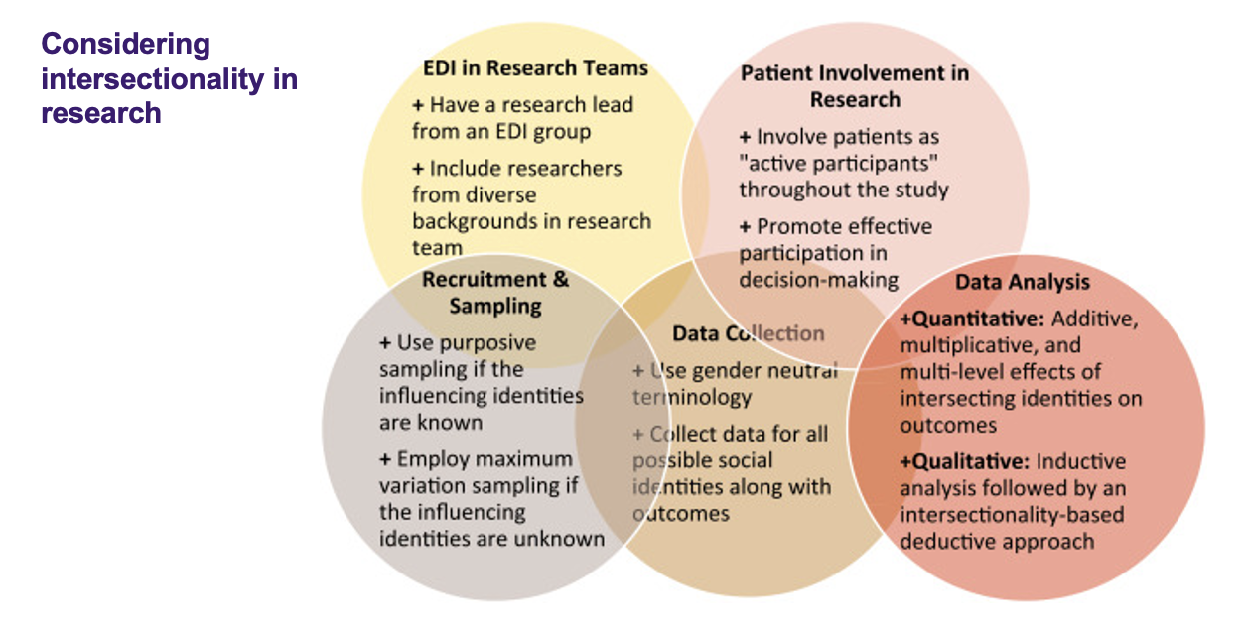
Class 3: EDI and Decolonization in research design and practice
January 13, 2025

Lecture notes:
Background
- Equity: tailored stragies ensuring fair and just opportunities for all indidvuals
- Diversity: embracing and valuing differences in perspectives, experiences, including identities, racial, ethnicity, gender, sexualaltiy, ability etc
- Inclusion: cerating an environment where everyone is valued and empowered to participat and contribute
- Decolonization: challenging and addressing the legacy of colonialism and euro western cetrism in research and academia
- Privilege: referes to adavantages, beenfits, or degrees of respect that an indidivuals or group is affored on the basse of their ideneitities. Operates on personal, interpersonal, cultural, and insistuional levels and benefits members of dominant groups at the expense of members from groups deemed outside of the domniant
- Power: the ability to decide who will va eaccess to resousces, insisituial power referes to the ability or official authority to decide what is best for others
- Equity deserving indidvuals and groups; a group pr community that has historically experienced systemic marginalization discrimination, or disadvantage based on various social identities such as race, ethnicity, gender, sexual orientation, disability, socioeconomic status, or other factors.
- Equity-deserving groups often face barriers to accessing resources, opportunities, and rights that are available to more privileged groups within society.
- The term "equity-deserving" emphasizes the need to address existing disparities and inequities by recognizing the historical and structural factors that have contributed to the exclusion of certain groups.
- It implies that these groups are deserving of equitable treatment and opportunities to mitigate systemic oppression and achieve fair outcomes.
Equity is the process, equality is the goal
- Equity requires the identification and removal of barriers, so that people of all identities and backgrounds are treated fairly
- This is done with informed and tailored approaches removing such barriers, leading to equal opportunities and access to resources

Recolinzation, decolinzation and indeginization
- Reconciliation: Acknowledging and addressing past wrongs done, speaking the truth
- Decolonization: Challenging and addressing the legacy of colonialism in research and academia
- Indigenization: Incorporating Indigenous Knowledge systems alongside and equal to Euro-western knowledge systems (not the replacement of either)
No diversity without inclusion
- This is accompanied by intentional
- efforts to inclusion
- Done by valuing respecting, and welcoming all
- Cultivating a sense of Belonging: being valued for you and what you bring to the table.
Why incorporate EDI and decolonization in research?
- Addressing historic and systemic biases and barriers in academia and research
- Shifts organizational and cultural values and practices
- Embedding EDID in our research ecosystem facilitates an
- inclusive and representative research community leading to:  Greater innovation and creativity in problem solving,
- Enhanced quality and relevance of research.
EDI in research funding
- Three core funding councils – tri-council:
- SSHRC - Social Sciences and Humanities Research Council CIHR - Canadian Institutes of Health Research
- NSERC - Natural Sciences and Engineering Research Council
EDI in Research funding?
- The EDI Objectives set out by tri-council:
- Fair access to tri-agency research support Equitable participation in the research system
- What does this look like in reality?
- How does tri-council encourage such advancements?
- Grant Guidelines, Criteria, Specific Sections Included in merit review of proposals
Equity, Diversity, Inclusion, and Decolonization in Research Design and Practice
Research Practice
- The research environment (in person, virtual, lab, field, etc.) where the research is conducted. Includes organizational systems, people, and culture, as well as recruitment and hiring practices.
- Your research team and environment
  - How do we consider a team, especially from a perspective of diversity?
    - Avoid sharing private demographic information
  - Instead:
    - First, describe your context - what groups are underrepresented in your research field/ department – how can you address this gap and barriers?
- Is the team diverse?
  - The static image - You have diverse identities and perspectives represented
  - Focus on HOW you arrived here, and not ‘how many diverse people are in my team’
  - The dynamic image - what are your mentorship and sponsorship practices to promote their growth, success and future careers?
- Starting the journey?
  - What concrete practices can you adopt to prepare your lab, and then consciously recruit more diverse members?
Diverse research teams
- Research Team Composition considerations:
  - Expterise
  - Identities
  - Education
  - Career stage
  - Life experience
- How could you recruit to achieve greater diversity?
  - Broader advertisement, encouraging applications, targeted outreach, non-gendered inclusive language, interview best practices
  - How could you change conditions to support retention?
  - Do the homework - this workshop and more
  - Promising onboarding practices, address isolation, work environment, accommodations, work-life balance
- How could you support successful careers?

Research design
- Inclusion and diversity of participants
- SGBA+
- Partnership in Research: Engaging
- community patients and partners (closely connected to Knowledge Mobilization)
- Refers to the design and process of research, including research questions, design of the study, methodology and data collection, analysis and interpretation, dissemination of results.
- How did I arrive at my research question?
- Who/what data am I hoping to engage/include in my research?
- Have I previously connected with said group/organization? Clinical populations, equity-deserving groups
- What barriers exist to inclusion of participation/data?
  - Animal Models
  - Cell samples
  - Human participants
  - Testing times, Distance to travel, Means of travel, Accessibility, Cultural competence
- Trying to better match the demographic representation of Canada (London) in your study population
  - Challenges of having more inclusive populations
  - Data interpretation
- Eventually thinking beyond research participants and subjects --> shifting to community engagement and co-creation
- In the example of clinical studies for example, the goal is to reduce health disparities, ensuring clinical findings reflect the demographic of Canada

EDID considerations in Research Design:
● Purpose: Steering Research Questions
● Research Questions: Applicability and Relevance
● Methodology
● Variables and Constructs
● Participant and Partner Engagement and Collaboration
● Research Ethics
● Data ownership and sovereignty ● Data Collection and Analysis
● Sampling
● Sex and Gender Based Analysis plus (SGBA+) ● Dissemination and Impact
● Knowledge Exchange + Translation
Sex and Gender Based Analysis: Terms
'Sex' ≠ 'gender'
Sex refers to a set of biological attributes in humans and animals. It is primarily associated with physical and physiological features including chromosomes, gene expression, hormone levels and function, and reproductive/sexual anatomy. Sex is usually categorized as female or male but there is variation in the biological attributes that comprise sex and how those attributes are expressed.
Terminology: male, female, intersex
Gender refers to the socially constructed roles, behaviours, expressions and identities of girls, women, boys, men, and gender diverse people. It influences how people perceive themselves and each other, how they act and interact, and the distribution of power and resources in society. Gender identity is not confined to a binary (girl/woman, boy/man) nor is it static; it exists along a continuum and can change over time.
• Gender Identity: How a person labels their own gender
• Gender Expression: How a person outwardly expresses their gender
• Gender Attribution: How others perceive a person’s gender
• Gender Roles: Imposed expectations and norms

Sex and Gender Based Analysis+ Beyond Sex and Gender
- SGBA+ is an analytical and EDI approach which accounts for key social determinants that may affect your research questions, including ethnicity, income, age, racial identity and education (and more).
- How are equity-deserving groups influenced by your research outcomes – and are they considered in your research discourse?
Community Driven Research
- Shifting to community-driven participatory research
- Directing, consulting and informing the direction of your research from the very beginning
- Involved at one stage vs. all stages.
- If you use the word partner, there is co-creation and co-development
- You have to build trust, respect, reciprocity to have a partnership
- Go beyond input from 1 participant/patient - include several perspectives - various lived experiences
The case for the inclusion of patient and community partners
- Relevance
- Ethical Considerations
- Improved Recruitment and Retention Enhanced Cultural Sensitivity
- Access to Hard-to-Reach Populations Knowledge Exchange and Capacity Building Social Impact - Promoting Health Equity
Class 4
January 15, 2025
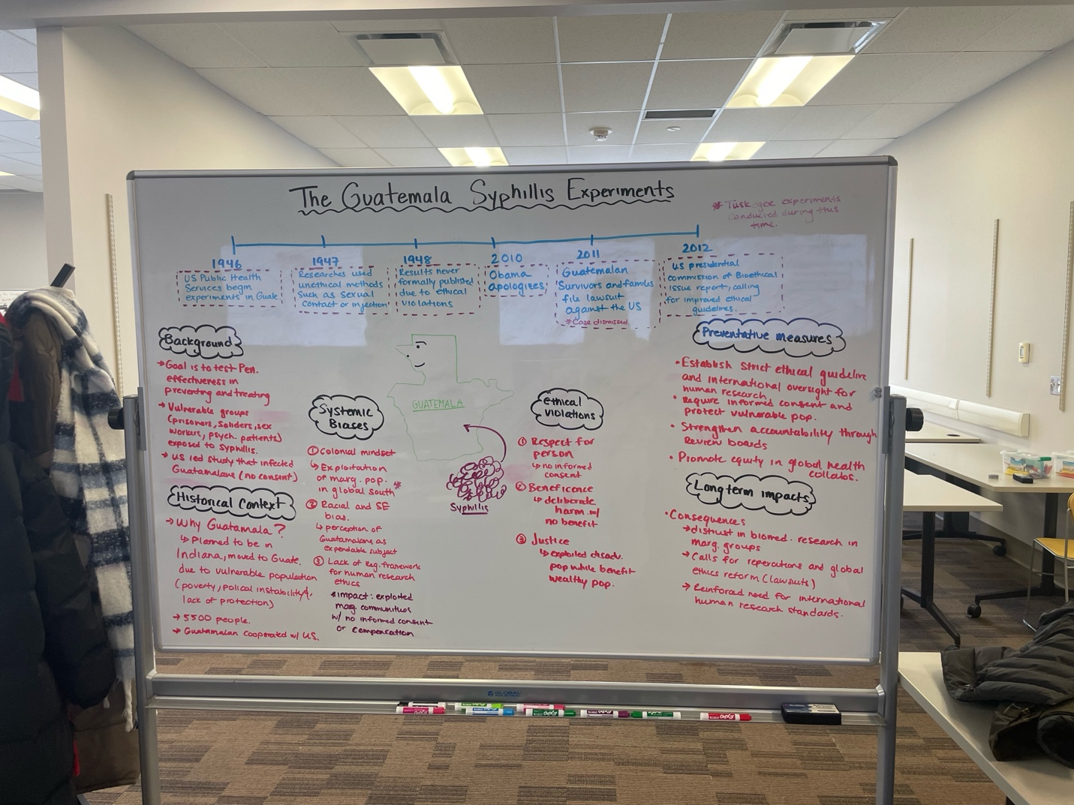
Class 5
January 20, 2025
Lecture notes
Cognitive imperialism
- a form of mental manipulation that aims to invalidate other knowledge systems and values. It's a form of colonization that can have destructive and traumatic effects on individuals and communities.
- Colonized ourselves, with a way of thinking
- English brain is very binary, right or wrong
  - Or mindset
  - This or that
- Indigenous language
  - And mindset
  - Multiple truths can be held
- Changing the mindset to and from or is a long process
- Marie batiste coined this term
- Happens and perpetuates by our education system
  - Prioritize one way of thinking, and how we do things
- Not only to indigenous, but to any minority groups in countries

Maslow’s hierarchy of needs
- Stolen from the Blackfoot people
- This is actually upside down
- Self-concept as a leaner esteem
- Belonging to group/ classroom/ CoP love/belong
- Emotional/ intellectual safety safety
- Syringes and sunglasses have invented by indigenous people

Introductions
In Indigenous communities, introductions are vital. Introductions begin the process of relationship building. Formal introductions (in the language) offer: name, clan, land and nation to which you belong.
Informally, introductions offer:
- Who you are in relation to the community
- Who you are connected to (who claims you)
- Your responsibilities (and intentions)
When working with Indigenous communities, being intentional about your introduction shows respect and gives people the opportunity (and info) to assess how they will engage with you.
The indigenous context in Canada
- Metis and Inuit
- Canada is called turtle island
Indigenous ways of knowing and being
- Indigenous refers to the original p0eople of a settled (colonised) land
- In Canada, indigenous people are the first nations, Metis, intuits
- At just over 1 million people, indigenous peoples represent slightly more than 5% of Canadas total population
- Oral histories place the various indigenous people of Canada as far back as 30 000 years
Indigenous knowledge is
- An ecosystem (relational)
- Fluid & nonlinear
- Pluralistic (many knowledges, many voices, not one Truth or Authority)
- Collectivist (co-constructed, for community)
- Embraces partiality
- Passed on through language and story (oral)
- Embedded in the land
- Animate
Discourse (Foucauldian triangle)
- Discourse as the constructs that constrain/contain knowledge spaces
- Looks at the (re)production of ‘truth’
- Concerned with the genealogy of knowledge – how things become to be understood as ‘true’ in society
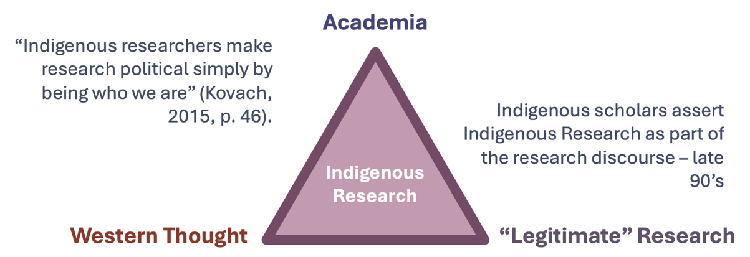

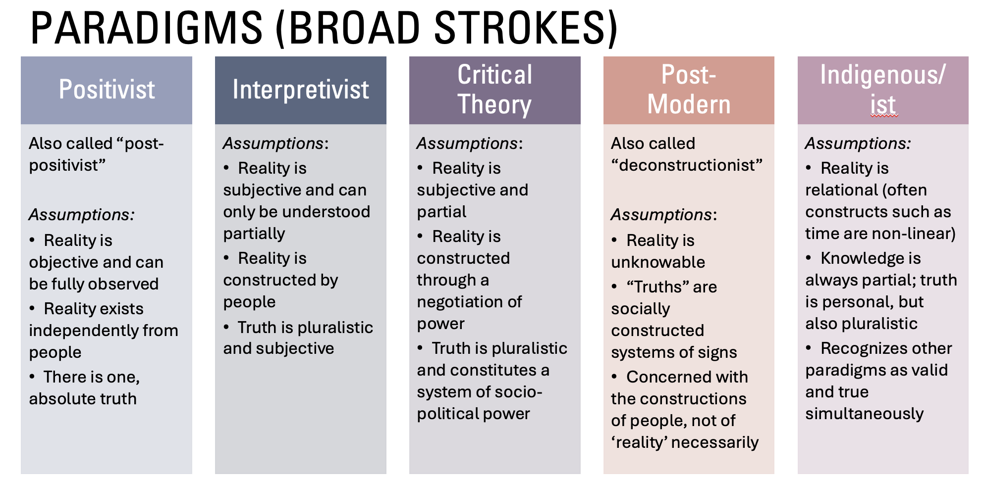
What is indigenous research
- Three ways to look at it:
  - Research carried out by Indigenous scholars and communities (Who?)
  - Research about/with Indigenous Knowledges, Peoples and/or issues (What?/Content)
  - Research that is rooted in Indigenous knowledge systems (How?)
- Because of this ambiguity, many Indigenous scholars choose to distinguish “Indigenous Research” (#1-2) and “Indigenous Research Methodologies” (#3).
Key Consideration
- WHO conducts Indigenous Research? (Relationality, positionality, subjectivity)
- Who SHOULD conduct Indigenous Research?
- Who HAS conducted Indigenous Research (historically)?
- How does this affect the discourse?
- WHY conduct Indigenous Research?
- Do the goals of your research study align with the values of Indigenous Research (Methodologies)?
- What permissions and connections do you have to the community with whom you wish to research?
- Will the research benefit the community?

Indigenous research methods (IRM)
- Major research
  - Based in relationships
  - Enacted through responsibilities
  - Self-determining
  - Works from an Indigenous Paradigm (informed by Indigenous ways of knowing, ways of being and value systems)
  - Can employ Indigenous and conventional (Western) methods for data collection and analysis
- Operation assumptions
  - Indigenous Knowledges are legitimate ways of knowing and being
  - Awareness of power and power imbalances within society generally and research specifically
  - Aims to highlight Indigenous voice and experience
  - Works toward transformational change
Relationality
- What does it mean to be ‘based in relationships? What relationships?
- IRM recognize the centrality of relationships to Indigenous ways of knowing, being and value systems. Research (and by extension, Knowledge) is understood to come out of relationships, which include:
- Researcher Community (Participants)
- Researcher Research
- Researcher Self
- Researcher Knowledge
- Researcher Knowledge Generated
- Researcher Land
Responsibility
- IRM are enacted through responsibilities; IRM is predicated on the acknowledgement and practice of these responsibilities to community, self and all of Creation.
- Some of these responsibilities include:
- Ensuring research benefits the community involved
- Building and maintaining respectful relationships
- Upholding nation/community sovereignty
- Contributing to transformational change
- Sustaining land and all living things
- Reflecting on and responding to the implications of one’s own social location
Self-determinism
- How are our methodologies self-determining?
- Asserts Indigenous Knowledges as legitimate
- Works to make Indigenous ways of knowing, ways of being and value systems normative
- Speaks back/writes back
- Brings Indigenous experience and voice to the fore
- Community relevant/community driven
- Codifies space in academia for Indigenous Thought
- Trailblazes methods and methodologies
Class 6
January 21, 2025
Lecture notes
Pragmatism in medical science
What is medical? What is medicine?
Medical (adjective)
- relating to the science of medicine, or to the treatment of illness and injuries.
2. relating to conditions requiring medical but not surgical treatment.
Medicine – (noun)
- the science or practice of the diagnosis, treatment, and prevention of disease (in technical use often taken to exclude surgery).
- a compound or preparation used for the treatment or prevention of disease, especially a drug or drugs taken by mouth.
What is Health? What is Science?
World Health Organization (W.H.O.) Definition of Health
“a state of complete physical, mental, and social well-being, and not merely the absence of disease or infirmity”
Science – (noun) – Latin scire (to know)
- the systematic study of the structure and behavior of the physical and natural world through observation, experimentation, and the testing of theories against the evidence obtained.
How do we do science?
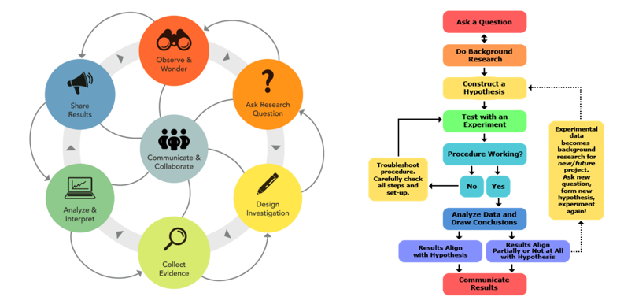
The Kuhn cycle
“A paradigm is a basic framework of assumptions, principals and methods from which the members of the community work.”
A set of norms that tell scientists how to think and behave, and although there are rival schools of thought in science, there is still a single paradigm accepted by all.
A paradigm shift is a fundamental change in the basic concepts
and experimental practices of a scientific discipline.
Science is soically construstced and cannot be decontexualized, a social process
Race
- Race is a term used to classify people into groups based principally on physical traits (phenotypes) such as skin colour. Racial categories are not based on science or biology but on differences that society has created (i.e., “socially constructed”). Race is not the same as ancestry. Racial categories may vary over time and place and can overlap with ethnic, cultural, or religious groupings (Ontario Government, 2022).
- Racism "is any attitude, action, institutional structure, or social policy that subordinates persons or groups because of their racial group membership“ (Sue and Spanierman, 2020).
- It is "prejudice plus power", which leads to disparities and inequities between groups of people based on their racial group because of the ideology of one race considered superior or inferior to another (Race Forward, 2023).

Article questions
How is race defined in this article?
- Race and ethnicity were self-reported by patients during hospital registration. Categories included Asian, Black or African American, Hispanic (non-Black), and White (non-Hispanic). Black Hispanic patients were categorized as Black for analysis due to their health outcomes aligning more closely with non-Hispanic Black patients.
What is being measured in the article?
- The article measures the accuracy of pulse oximetry (SpO2) compared to arterial oxygen saturation (SaO2) among patients with COVID-19 across different racial and ethnic groups. It evaluates the frequency of occult hypoxemia (where SpO2 overestimates SaO2) and examines its association with delays in recognizing eligibility for oxygen threshold-specific COVID-19 therapies.
What are the conclusions the authors made?
- Pulse oximetry overestimated oxygen saturation in Asian, Black, and Hispanic patients compared to White patients.
- Occult hypoxemia was more common in these minority groups, leading to unrecognized or delayed recognition of treatment eligibility.
- Black and Hispanic patients were disproportionately affected, with Black patients experiencing significant delays in treatment eligibility recognition.
Do the outcomes exemplify a racial inequity?
- Yes, the outcomes exemplify racial inequity. The inaccuracy of pulse oximetry disproportionately affected minority groups, leading to delayed or missed eligibility for COVID-19 treatments, which could contribute to worse health outcomes in these populations.
What are the implications of the findings and conclusions?
- The findings highlight the need for improvements in pulse oximetry technology to ensure accurate readings across all skin tones.
- These discrepancies could exacerbate existing health disparities and call for greater awareness in clinical practice to account for potential inaccuracies in treatment decisions.
- There is a need for innovation, such as integrating additional wavelengths or calibration based on skin pigmentation, to address these biases and ensure equitable healthcare delivery.

Class 7:
January 27, 2025

Lecture Notes
EDI statements in context
- Importance/need/emergence of EDI statements Positionality
- Personal statements, unit level - departments and organizations, and institutional
- Statement serves as both a public commitment and a guide for the organization in addressing challenges related to diversity, equity, and inclusion
EDI statements
- Acknowledging systemic oppression, and importance of EDI A declaration of commitment to fostering EDI
- Ideally, emphasizes goals and actions to address barriers outlined
- Ideally, describes how a more inclusive and supportive environment will be cultivated
- Ideally, outlines tangible metrics for assessing if this is moving in the right direction

Forms of Health Equity Chairs
- Research Equity Charters
- Healthcare Institutional Equity Charters
- Global Health Equity Frameworks

Key components of a charter
- Commitment of equity and inclusion (why is a Charter necessary)
- Statement of values
- Strategic SMART actions (in support of values that address barriers & inequities e.g., anti-discrimination)
- Accountability mechanisms
- Resource allocation
- Public declaration via a social contract

Definition of equity Charter
- Express formal commitments made by organizations (including research institutions, hospitals, and healthcare systems) to prioritize and achieve equity via addressing barriers/inequities in their policies, research, healthcare delivery, and community engagement
Critques of charters
- Lack of implementation and action
  - Vague, not measurable
  - Tokenism/Virtue Signaling
- Lack of resource allocation or action plans
- Over-reliance on policies without cultural change
  - Surface-level solutions
  - Resistance to change
- Limited scope
  - Focus on diversity over equity & inclusion

Importance of Charters
- Promoting and addressing equity and social justice
- Legal and ethical responsibility
- Building reputation and public trust
- Empowering underrepresented groups
- Advocacy

Definition of advocacy
- Involves efforts to influence public opinion, decisions, or legislation to create positive change on behalf of a particular issue/community/interest
- Act of supporting/recommending a cause, policy, or group of people
- Advocacy can take many forms, ranging from lobbying politicians and organizing protests to educating the public or engaging in legal action
Key aspects of advocacy
- Purpose driven
- Representation
- Collaboration
- Influencing change
Health equity advocacy
- Involves:
  - Raise awareness about the existence of health disparities
- Mobilize communities to address the root causes of health inequities
- Influence policymakers to implement fair health policies 4. Improve access to resources, including healthcare, education, housing, and healthy food
- Ensure community participation in decision-making about their own health

Key concepts in. health equity advocacy
- Social Determinants of Health (health is not just determined by medical care)
- Structural inequities rooted in policies, systems and norms
- Cultural Competence
- Intersectionality
Strategies for Effective Health Equity Advocacy
- Remember the forms of Charters?
- Research Advocacy: inclusion of underrepresented populations
- Public Health and Policy Advocacy: equitable health policies
- Community-Based Advocacy: Collaborating with communities at the local level
- Public education and awarness: using data stories, and campaigns to raise awareness
- Legal Advocacy: use litigation to challenge discriminatory practices/health policies in courts
- Partnerships and collaboration

Challenges in Health Advocacy
- Political and economic barriers
- Public resistance and misinformation
- Lack of resources
- Data Gaps

