MEDSCI 9502
Lecture 6
Monday October 28, 2024

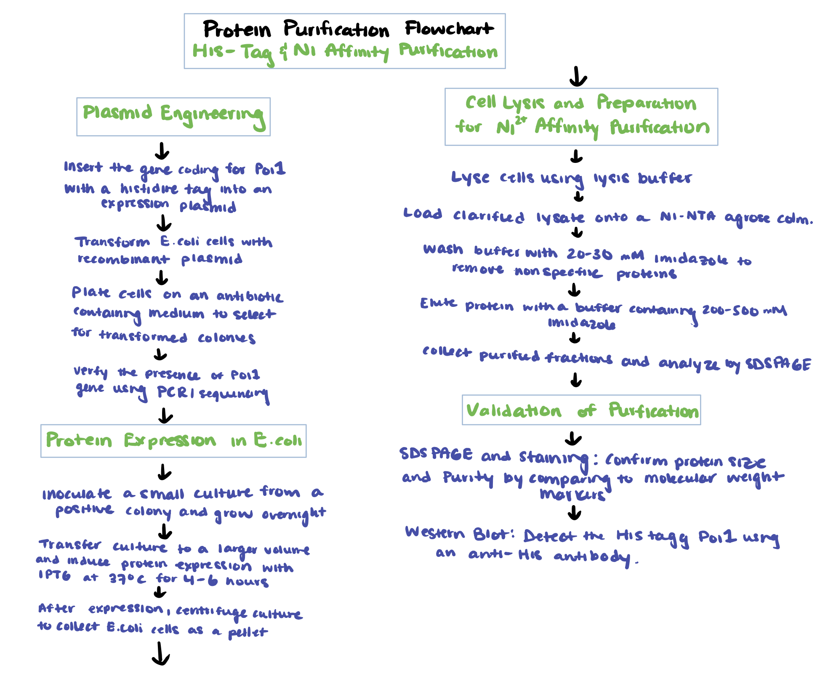
Presession task

